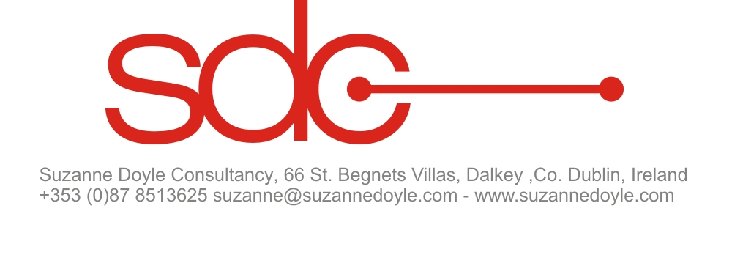 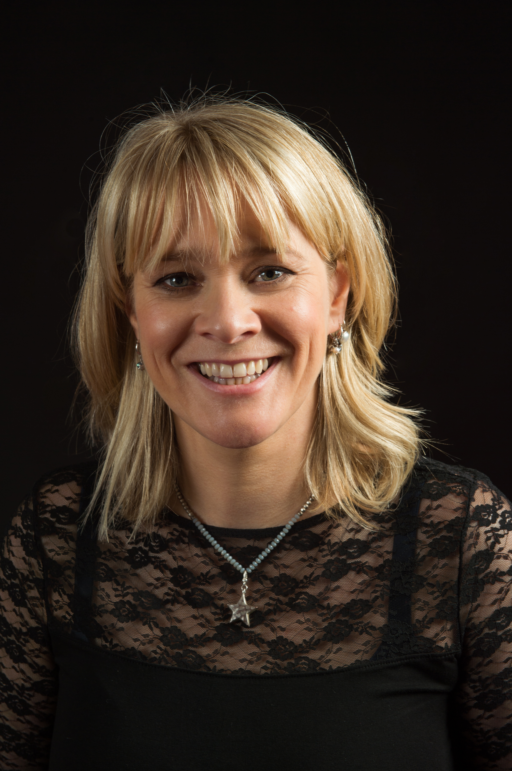 Photo by Ruth Medjber
Biography - Suzanne Doyle – Nov 2025
Suzanne Doyle’s career has spanned many aspects of the arts, including artist management, music release/promotion, press/ marketing, tour/event management and film/TV production.
In 1987 she joined Principle Management working directly with U2 and manager Paul McGuinness on the day-to-day running of the band’s business including albums, tours and press & promotion. Keen to broaden her international experience, in 1990 she relocated to Australia, where she worked for independent label rooArt Records.
From 1993-96, she was Talent & Artist Relations Manager for MTV Europe representing Independent labels at the weekly Playlist Meeting, dealing with managers and publicists, while also working one-on-one with music legends & super-models at MTV events around Europe.
Suzanne was lured back to Principle twice more when she was Management Associate on U2’s ‘Zoo TV’ and ‘Pop’ world tours. In 1999, she became Personal Assistant to Bono & Ali Hewson.
In 2002, she decided to utilise her wealth of contacts and experience, launching Suzanne Doyle Consultancy. Credits include working with Paddy Cosgrave on the Dublin Web Summit & Founders in 2014, liaising closely with Kevin Godley as Director of Talent & Artist Relations on his audio/visual app ‘WholeWorldBand’ for which she developed a strategy to source content, attracting investment of €5million approx. She produced Irish band Kíla’s concert film - ‘Once Upon A Time’ - featuring endorsements from luminaries such as Neil Jordan and Pat McCabe, and a one-hour special airing on RTÉ - ‘A Christmas Celebration with Eimear Quinn’ - directed by Philip King. Working with Warner Brothers, she produced ‘The Brilliant Irish Flute’ - a high-end double CD/book that went to No. 1 in the Irish iTunes World Music Charts.
In 2015 RTÉ Television approached Suzanne to work as Music Associate on The Imelda May Show, on RTÉ 1. She was then hired by RTÉ 2 to work as Artist Liaison for their broadcast from Electric Picnic until it ceased in 2017. When the current Music Supervisor of RTÉ Television’s flagship show, The Late Late Show, was temporarily moved to work on the 2016 Centenary Show, Suzanne was hired as Music Associate from Sept 2015 – March 2016. She continued to work in this capacity with RTÉ on a consultancy basis until the Covid19 pandemic.
In Autumn 2017 Suzanne was hired to work as Executive Assistant with International comedian, TV presenter and actor, Tommy Tiernan, for 12 months when there was a change in his mgmt. team.
Working in a management capacity with Achill based singer /songwriter Graham Sweeney, a new album ‘Isle of the Eagle’ was released in Aug 2023 with his new collective group The Achill Sound, and until end 2021 Suzanne managed the acclaimed international singer/songwriter Declan O’Rourke and specifically on the release of his Paul Weller produced 7th album, ‘Arrivals’ to critical acclaim.
Until retirement at the end of 2023, Suzanne creatively managed legendary Irish artist Finbar Furey, releasing ‘Don’t Stop This Now’ CD/DVD with BMG UK in 2018, and ‘Moments in Time’ Sept 2023.
She is currently managing 25yr old singer/songwriter, multi-instrumentalist Lorraine Nash who is releasing Deluxe version of her debut Album ‘All That I Can Be’ Jan 2025, and previously worked as Consultant Manager with The White Horse Guitar Club helping them grow from strength to strength, completing 2 Irish Tours, and a ‘performance of a lifetime’ at Áras an Uachtaráin for Irish President, Michael D. Higgins & his wife Sabina Higgins, on Culture Night Sept 2023.
Suzanne is a Mentor at Minding Creative Minds which is free 24/7 wellbeing support programme for the creative sector. She was one of the elected members to the Steering Committee of AIM Ireland, (The Association of Independent Music Ireland), a new Irish trade organisation, linked with UK, USA and Europe; all with a common mission to promote growth, awareness and opportunities for independent music through advocacy, education and community.
In 2024, Suzanne was elected as a new member of Folk/Global Network Steering Committee, at European Music Managers Alliance (EMMA) https://emma.community/
Since 2024 she has been managing singer/songwriter and multi-instrumentalist Lorraine Nash, who successfully completed a Kickstarter campaign in 2025 to fund the recording of her highly anticipated second album. The project is being co-produced with Grammy-winning musician and producer Ron Block, known for his work with Alison Krauss & Union Station.
Periodically throughout her life, Suzanne has volunteered for various charities at home and overseas, raising awareness, and at times necessary funds. This included creating & producing one-off events eg. ‘Postcard from Ethiopia’ raising €100k+ for Concern Worldwide and ‘What Goes Around Comes Around’ a stand-alone event benefitting Irish charities Aware, Alzheimer’s Society, Irish Cancer Society, Jack & Jill Foundation and Bray Women’s Refuge. In 2008 Suzanne raised money to travel to India with the Hope Foundation charity, who support children and homeless families living on the streets & slums of Kolkata. In early 2022, Suzanne was involved in her local community of Dun Laoghaire raising funds and supporting Ukrainian people arriving to Ireland when war broke out. In 2024 and 2025 she has been actively volunteering with Mothers Against Genocide, and Pals For Palestine raising awareness and funds for Gaza, with two musical releases ‘Song for Palestine’ by Ellen O’Meara, and a haunting new version of Eleanor McEvoy’s classic song 'A Woman’s Heart' named 'A Mother’s Heart for Palestine' in solidarity with the mothers of Palestine, performed by the MAG Choir, featuring Mary Black, Róisín el Cherif, Ríoghnach Connolly, Áine Tyrrell, Leen, Sailhymn and Kanun player, Aziz Abushark.

